**Exercise 1: Control Structures**

**Scenario 1:** The bank wants to apply a discount to loan interest rates for customers above 60 years old.

* + **Question:** Write a PL/SQL block that loops through all customers, checks their age, and if they are above 60, apply a 1% discount to their current loan interest rates.

BEGIN

FOR c IN (SELECT CustomerID, DOB FROM Customers) LOOP

IF MONTHS_BETWEEN(SYSDATE, c.DOB) / 12 > 60 THEN

UPDATE Loans

SET InterestRate = InterestRate - 1

WHERE CustomerID = c.CustomerID;

DBMS_OUTPUT.PUT_LINE('Applied 1% discount to customer ID: ' || c.CustomerID);

END IF;

END LOOP;

COMMIT;

END;

/

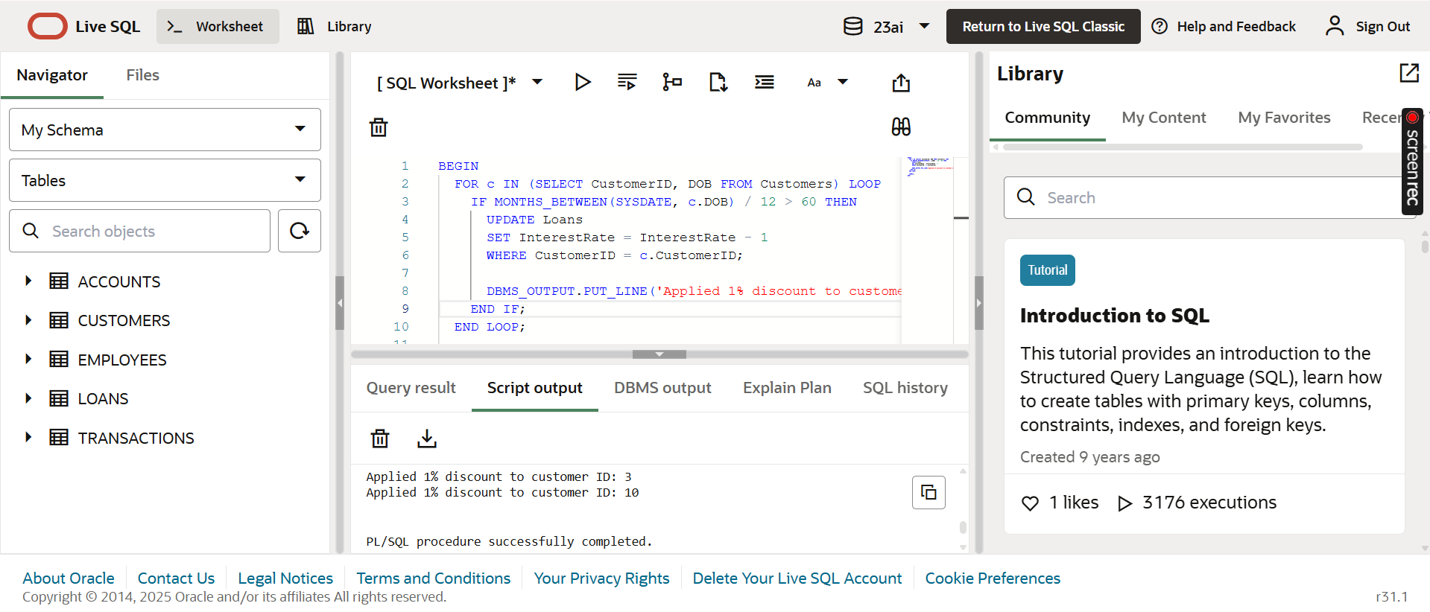

**Scenario 2:** A customer can be promoted to VIP status based on their balance.

* + **Question:** Write a PL/SQL block that iterates through all customers and sets a flag IsVIP to TRUE for those with a balance over $10,000.

alter table CUSTOMERS add (IsVIP CHAR(1));

begin

    for c in (select CustomerID,Balance from CUSTOMERS) loop

     IF c.Balance>10000 then

        update Customers

        set IsVIP='Y'

        where CustomerID=c.CustomerID;

     else

        update Customers

        set IsVIP='N'

        where CustomerID=c.CustomerID;

     end if;

    end loop;

    COMMIT;

    end;

    /

    select * from CUSTOMERS;

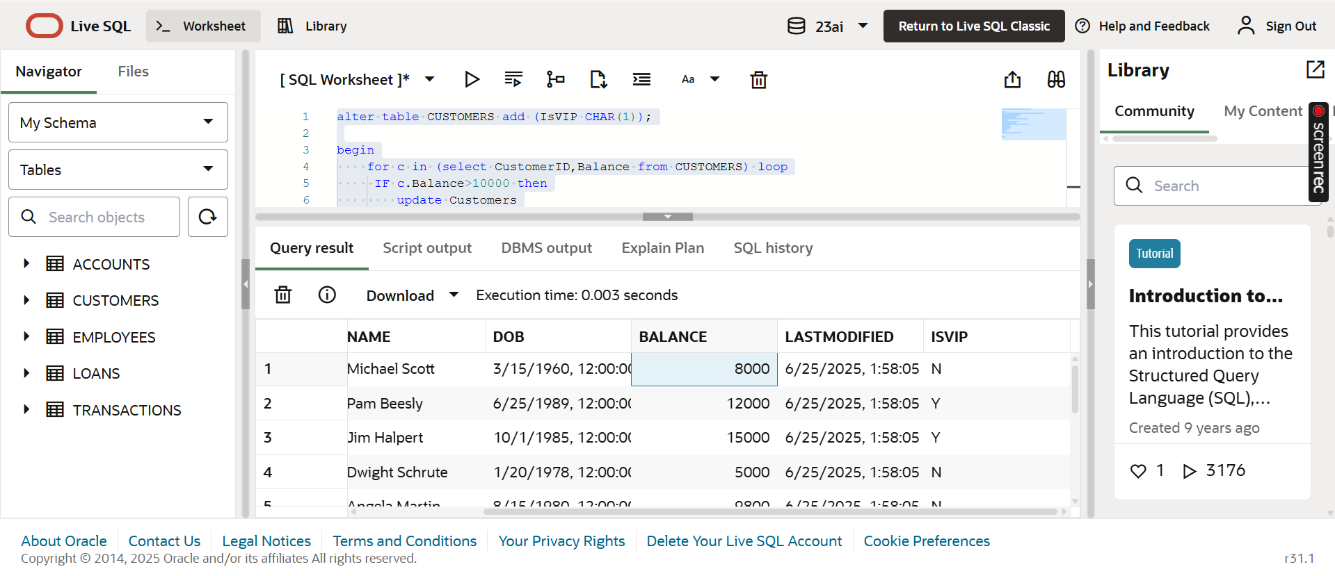

**Scenario 3:** The bank wants to send reminders to customers whose loans are due within the next 30 days.

* + **Question:** Write a PL/SQL block that fetches all loans due in the next 30 days and prints a reminder message for each customer.

BEGIN

  FOR l IN (

    SELECT l.LoanID, l.CustomerID, c.Name, l.ENDDATE

    FROM Loans l

    JOIN Customers c ON c.CustomerID = l.CustomerID

    WHERE l.ENDDATE BETWEEN SYSDATE AND SYSDATE + 30

  ) LOOP

    DBMS_OUTPUT.PUT_LINE('Reminder: Loan ID ' || l.LoanID ||

                         ' for customer ' || l.Name ||

                         ' is due on ' || TO_CHAR(l.ENDDATE, 'DD-MON-YYYY'));

  END LOOP;

END;

/

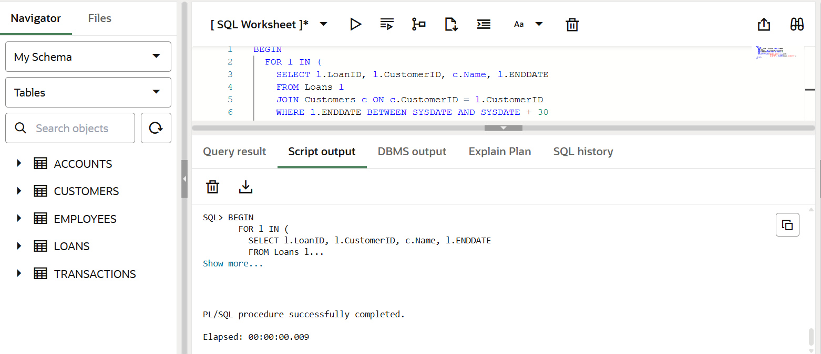

**Exercise 2: Error Handling**

**Scenario 1:** Handle exceptions during fund transfers between accounts.

* + **Question:** Write a stored procedure **SafeTransferFunds** that transfers funds between two accounts. Ensure that if any error occurs (e.g., insufficient funds), an appropriate error message is logged and the transaction is rolled back.

CREATE OR REPLACE PROCEDURE SafeTransferFunds (

  p_from_account_id IN NUMBER,

  p_to_account_id   IN NUMBER,

  p_amount          IN NUMBER

) AS

  v_from_balance NUMBER;

BEGIN

  SELECT Balance INTO v_from_balance

  FROM Accounts

  WHERE AccountID = p_from_account_id

  FOR UPDATE;

  IF v_from_balance < p_amount THEN

    RAISE_APPLICATION_ERROR(-20001, 'Insufficient funds in source account.');

  END IF;

  UPDATE Accounts

  SET Balance = Balance - p_amount

  WHERE AccountID = p_from_account_id;

  UPDATE Accounts

  SET Balance = Balance + p_amount

  WHERE AccountID = p_to_account_id;

  COMMIT;

  DBMS_OUTPUT.PUT_LINE('Transfer successful: ' || p_amount || ' transferred from Account ' ||

                        p_from_account_id || ' to Account ' || p_to_account_id);

EXCEPTION

  WHEN OTHERS THEN

    -- Rollback the whole transaction in case of any error

    ROLLBACK;

    DBMS_OUTPUT.PUT_LINE('Transfer failed: ' || SQLERRM);

END;

/

BEGIN

  SafeTransferFunds(1, 2, 500);

END;

/

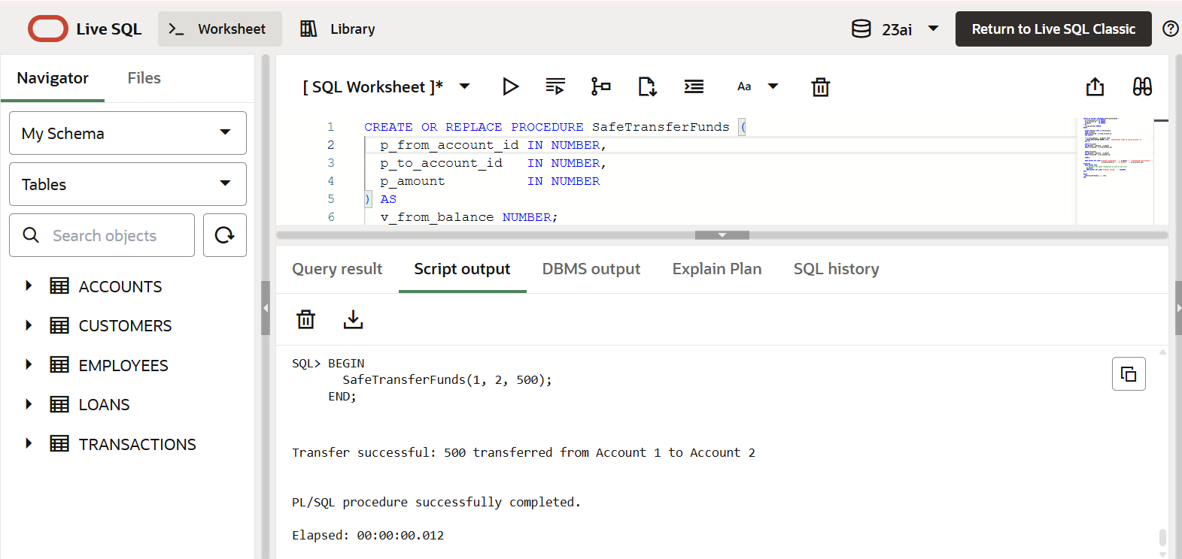

**Scenario 2:** Manage errors when updating employee salaries.

* + **Question:** Write a stored procedure **UpdateSalary** that increases the salary of an employee by a given percentage. If the employee ID does not exist, handle the exception and log an error message.

CREATE OR REPLACE PROCEDURE UpdateSalary (

  p_employee_id     IN NUMBER,

  p_percentage_incr IN NUMBER

) AS

  v_current_salary NUMBER;

BEGIN

  SELECT Salary INTO v_current_salary

  FROM Employees

  WHERE EmployeeID = p_employee_id

  FOR UPDATE;

  UPDATE Employees

  SET Salary = Salary + (Salary * p_percentage_incr / 100)

  WHERE EmployeeID = p_employee_id;

  COMMIT;

  DBMS_OUTPUT.PUT_LINE('Salary updated successfully for Employee ID: ' || p_employee_id);

EXCEPTION

  WHEN NO_DATA_FOUND THEN

    DBMS_OUTPUT.PUT_LINE('Error: Employee with ID ' || p_employee_id || ' does not exist.');

  WHEN OTHERS THEN

    DBMS_OUTPUT.PUT_LINE('Unexpected error: ' || SQLERRM);

    ROLLBACK;

END;

/

BEGIN

  UpdateSalary(2, 10);

END;

/

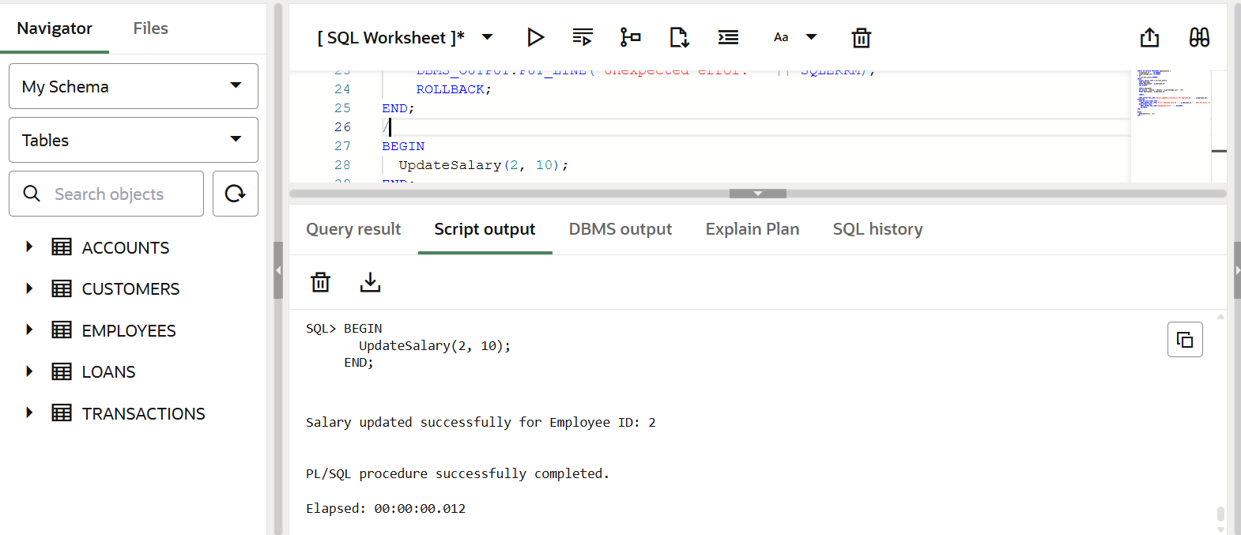

**Scenario 3:** Ensure data integrity when adding a new customer.

* + **Question:** Write a stored procedure **AddNewCustomer** that inserts a new customer into the Customers table. If a customer with the same ID already exists, handle the exception by logging an error and preventing the insertion.

CREATE OR REPLACE PROCEDURE AddNewCustomer (

  p_customer_id   IN NUMBER,

  p_name          IN VARCHAR2,

  p_dob           IN DATE,

  p_balance       IN NUMBER

) AS

BEGIN

  INSERT INTO Customers (CustomerID, Name, DOB, Balance, LastModified)

  VALUES (p_customer_id, p_name, p_dob, p_balance, SYSDATE);

  COMMIT;

  DBMS_OUTPUT.PUT_LINE('Customer added successfully: ' || p_customer_id || ' - ' || p_name);

EXCEPTION

  WHEN DUP_VAL_ON_INDEX THEN

    DBMS_OUTPUT.PUT_LINE('Error: Customer with ID ' || p_customer_id || ' already exists.');

  WHEN OTHERS THEN

    DBMS_OUTPUT.PUT_LINE('Unexpected error: ' || SQLERRM);

    ROLLBACK;

END;

/

BEGIN

  AddNewCustomer(13, 'Dharshini', TO_DATE('1980-01-01', 'YYYY-MM-DD'), 3000);

END;

/

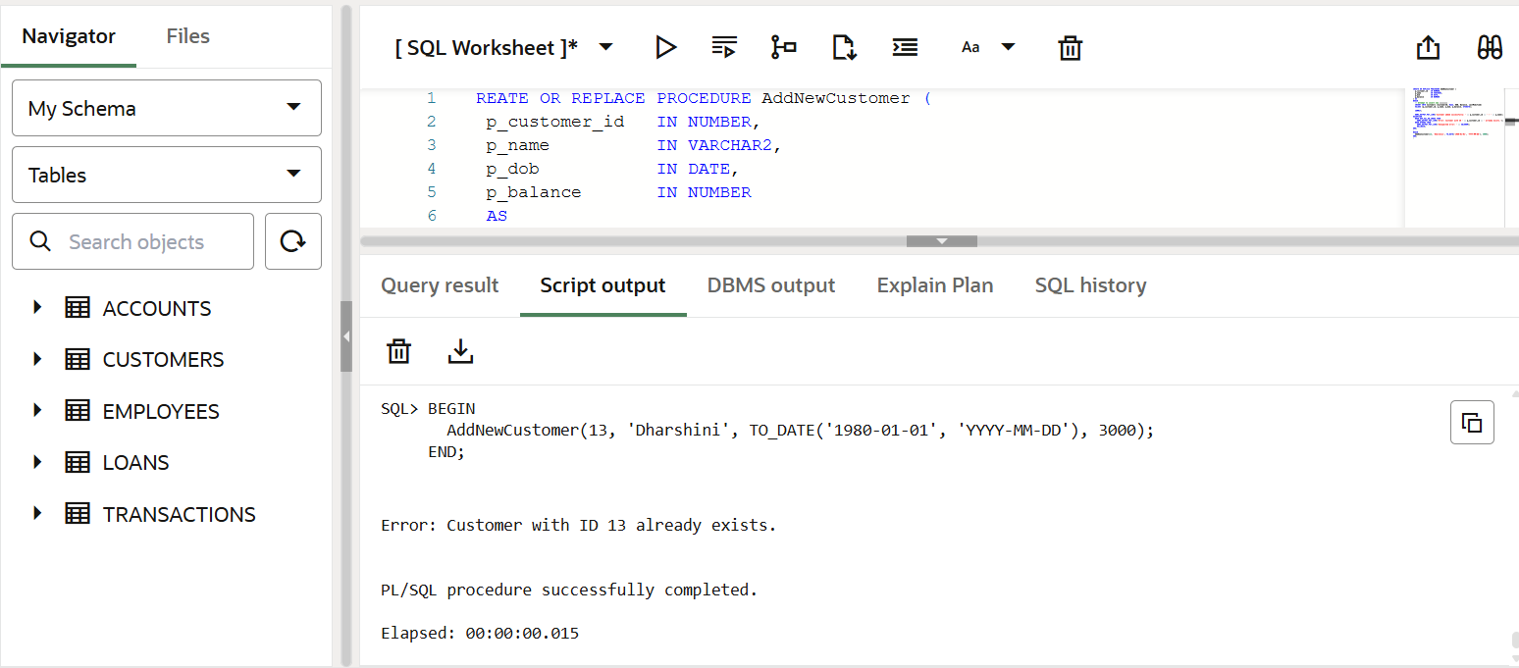

**Exercise 3: Stored Procedures**

**Scenario 1:** The bank needs to process monthly interest for all savings accounts.

* + **Question:** Write a stored procedure **ProcessMonthlyInterest** that calculates and updates the balance of all savings accounts by applying an interest rate of 1% to the current balance.

CREATE OR REPLACE PROCEDURE ProcessMonthlyInterest IS

BEGIN

  FOR acc IN (

    SELECT AccountID, Balance

    FROM Accounts

    WHERE AccountType = 'Savings'

    FOR UPDATE

  ) LOOP

    UPDATE Accounts

    SET Balance = Balance + (acc.Balance * 0.01)

    WHERE AccountID = acc.AccountID;

    DBMS_OUTPUT.PUT_LINE('Interest applied to Account ID: ' || acc.AccountID ||

                         ' | New Balance approx: ' || TO_CHAR(acc.Balance * 1.01, '999999.99'));

  END LOOP;

  COMMIT;

END;

/

BEGIN

    ProcessMonthlyInterest;

end;

/

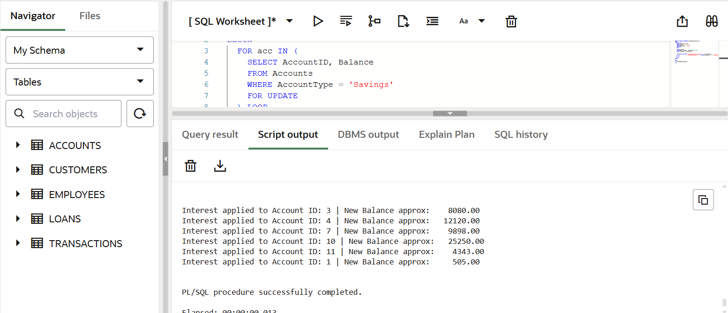

**Scenario 2:** The bank wants to implement a bonus scheme for employees based on their performance.

* + **Question:** Write a stored procedure **UpdateEmployeeBonus** that updates the salary of employees in a given department by adding a bonus percentage passed as a parameter.

CREATE OR REPLACE PROCEDURE UpdateEmployeeBonus (

  p_department     IN VARCHAR2,

  p_bonus_percent  IN NUMBER

) AS

BEGIN

  FOR emp IN (

    SELECT EmployeeID, Name, Salary

    FROM Employees

    WHERE Department = p_department

    FOR UPDATE

  ) LOOP

    UPDATE Employees

    SET Salary = Salary + (Salary * p_bonus_percent / 100)

    WHERE EmployeeID = emp.EmployeeID;

    DBMS_OUTPUT.PUT_LINE('Bonus applied to ' || emp.Name ||

                         ' | New Salary approx: ' || TO_CHAR(emp.Salary * (1 + p_bonus_percent / 100), '999999.99'));

  END LOOP;

  COMMIT;

END;

/

BEGIN

    UpdateEmployeeBonus('IT',10);

end;

/

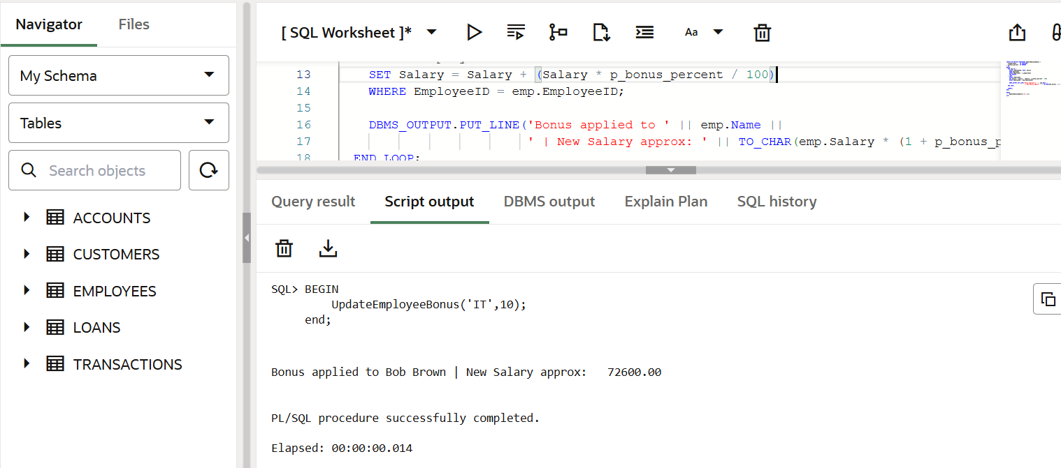

**Scenario 3:** Customers should be able to transfer funds between their accounts.

* + **Question:** Write a stored procedure **TransferFunds** that transfers a specified amount from one account to another, checking that the source account has sufficient balance before making the transfer.

CREATE OR REPLACE PROCEDURE TransferFunds (

  p_from_account_id IN NUMBER,

  p_to_account_id   IN NUMBER,

  p_amount          IN NUMBER

) AS

  v_from_balance NUMBER;

BEGIN

  SELECT Balance INTO v_from_balance

  FROM Accounts

  WHERE AccountID = p_from_account_id

  FOR UPDATE;

  IF v_from_balance < p_amount THEN

    DBMS_OUTPUT.PUT_LINE('Transfer failed: Insufficient funds in source account.');

    RETURN;

  END IF;

  UPDATE Accounts

  SET Balance = Balance - p_amount

  WHERE AccountID = p_from_account_id;

  UPDATE Accounts

  SET Balance = Balance + p_amount

  WHERE AccountID = p_to_account_id;

  COMMIT;

  DBMS_OUTPUT.PUT_LINE('Transfer successful: ' || p_amount ||

                       ' transferred from Account ' || p_from_account_id ||

                       ' to Account ' || p_to_account_id);

EXCEPTION

  WHEN NO_DATA_FOUND THEN

    DBMS_OUTPUT.PUT_LINE('Transfer failed: One of the accounts does not exist.');

  WHEN OTHERS THEN

    ROLLBACK;

    DBMS_OUTPUT.PUT_LINE('Transfer failed: ' || SQLERRM);

END;

/

BEGIN

    TransferFunds(1,2,300);

END;

/

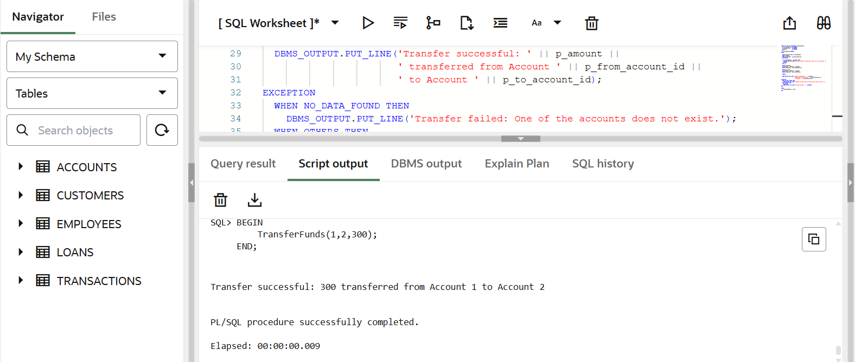

**Exercise 4: Functions**

**Scenario 1:** Calculate the age of customers for eligibility checks.

* + **Question:** Write a function CalculateAge that takes a customer's date of birth as input and returns their age in years.

CREATE OR REPLACE FUNCTION CalculateAge (

  p_dob IN DATE

) RETURN NUMBER IS

  v_age NUMBER;

BEGIN

  v_age := FLOOR(MONTHS_BETWEEN(SYSDATE, p_dob) / 12);

  RETURN v_age;

END;

/

DECLARE

  v_age NUMBER;

BEGIN

  v_age := CalculateAge(TO_DATE('1995-07-20', 'YYYY-MM-DD'));

  DBMS_OUTPUT.PUT_LINE('Age: ' || v_age);

END;

/

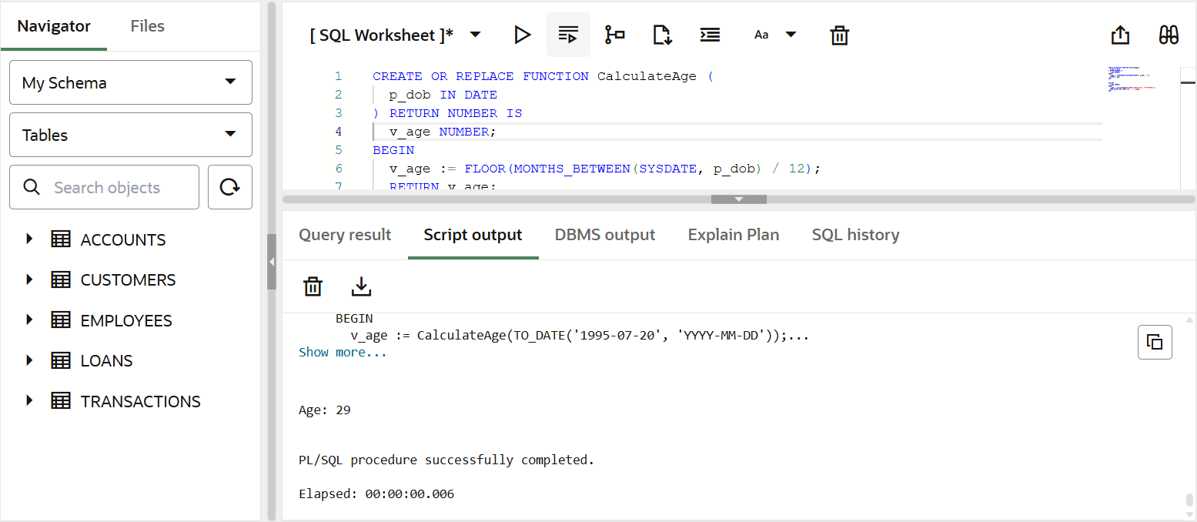

**Scenario 2:** The bank needs to compute the monthly installment for a loan.

* + **Question:** Write a function **CalculateMonthlyInstallment** that takes the loan amount, interest rate, and loan duration in years as input and returns the monthly installment amount.

CREATE OR REPLACE FUNCTION CalculateAge (

  p_dob IN DATE

) RETURN NUMBER IS

  v_age NUMBER;

BEGIN

  v_age := FLOOR(MONTHS_BETWEEN(SYSDATE, p_dob) / 12);

  RETURN v_age;

END;

/

DECLARE

  v_age NUMBER;

BEGIN

  v_age := CalculateAge(TO_DATE('1995-07-20', 'YYYY-MM-DD'));

  DBMS_OUTPUT.PUT_LINE('Age: ' || v_age);

END;

/

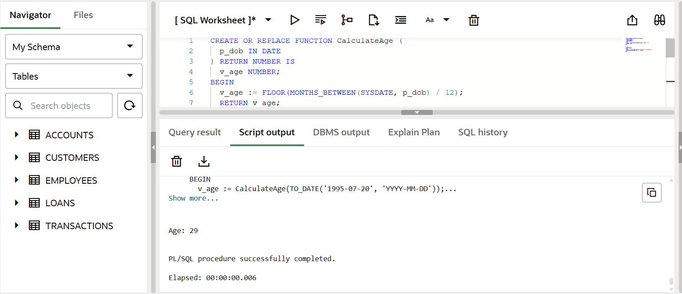

**Scenario 3:** Check if a customer has sufficient balance before making a transaction.

* + **Question:** Write a function **HasSufficientBalance** that takes an account ID and an amount as input and returns a boolean indicating whether the account has at least the specified amount.

CREATE OR REPLACE FUNCTION HasSufficientBalance (

  p_account_id IN NUMBER,

  p_amount     IN NUMBER

) RETURN BOOLEAN IS

  v_balance NUMBER;

BEGIN

  SELECT Balance INTO v_balance

  FROM Accounts

  WHERE AccountID = p_account_id;

  RETURN v_balance >= p_amount;

EXCEPTION

  WHEN NO_DATA_FOUND THEN

    RETURN FALSE;

  WHEN OTHERS THEN

    RETURN FALSE;

END;

/

DECLARE

  result BOOLEAN;

BEGIN

  result := HasSufficientBalance(1, 500);

  IF result THEN

    DBMS_OUTPUT.PUT_LINE('Sufficient balance');

  ELSE

    DBMS_OUTPUT.PUT_LINE('Insufficient balance');

  END IF;

END;

/

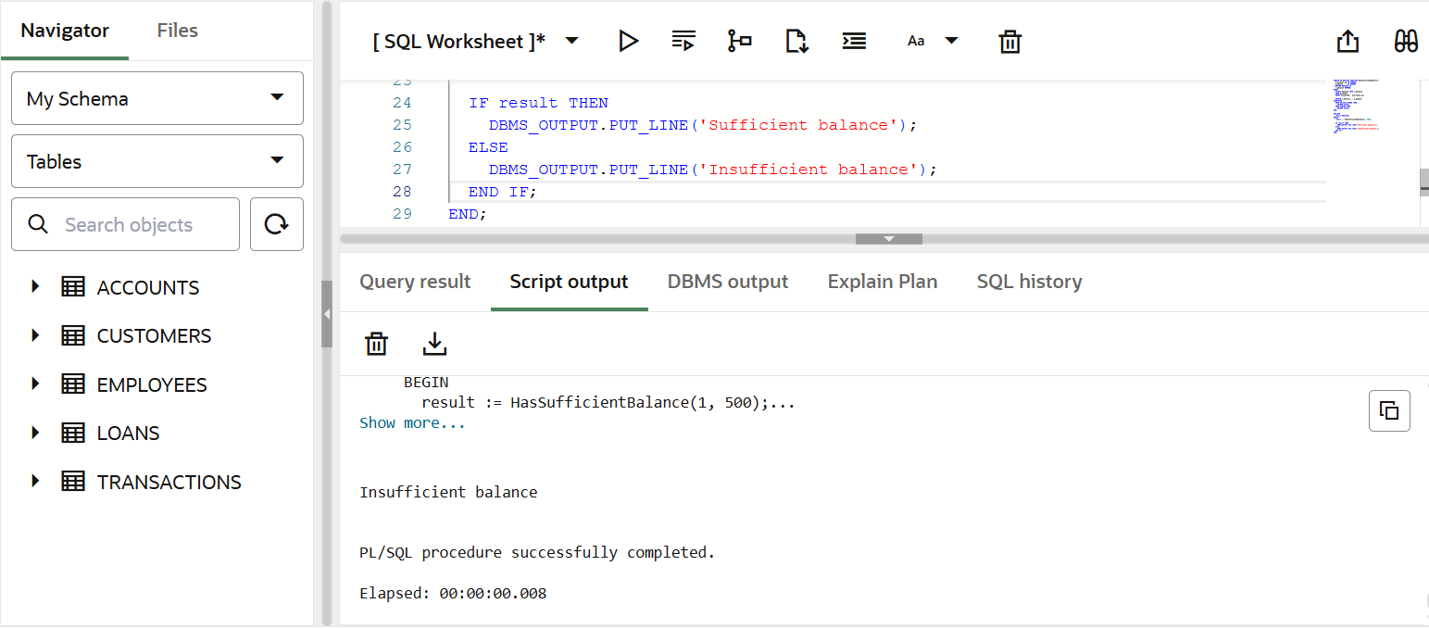

**Exercise 5: Triggers**

**Scenario 1:** Automatically update the last modified date when a customer's record is updated.

* + **Question:** Write a trigger **UpdateCustomerLastModified** that updates the LastModified column of the Customers table to the current date whenever a customer's record is updated.

CREATE OR REPLACE TRIGGER UpdateCustomerLastModified

BEFORE UPDATE ON Customers

FOR EACH ROW

BEGIN

  :NEW.LastModified := SYSDATE;

END;

/

UPDATE Customers

SET Balance = Balance + 100

WHERE CustomerID = 1;

SELECT Name, Balance, LastModified

FROM Customers

WHERE CustomerID = 1;

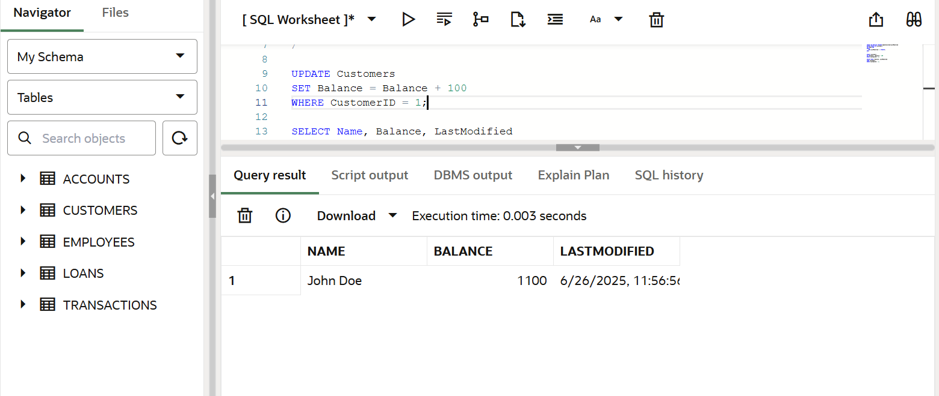

**Scenario 2:** Maintain an audit log for all transactions.

* + **Question:** Write a trigger **LogTransaction** that inserts a record into an AuditLog table whenever a transaction is inserted into the Transactions table.

CREATE TABLE AuditLog (

LogID NUMBER GENERATED BY DEFAULT AS IDENTITY PRIMARY KEY,

TransactionID NUMBER,

AccountID NUMBER,

Amount NUMBER,

TransactionType VARCHAR2(10),

LoggedAt DATE

);

CREATE OR REPLACE TRIGGER LogTransaction

AFTER INSERT ON Transactions

FOR EACH ROW

BEGIN

INSERT INTO AuditLog (

TransactionID,

AccountID,

Amount,

TransactionType,

LoggedAt

) VALUES (

:NEW.TransactionID,

:NEW.AccountID,

:NEW.Amount,

:NEW.TransactionType,

SYSDATE

);

END;

/

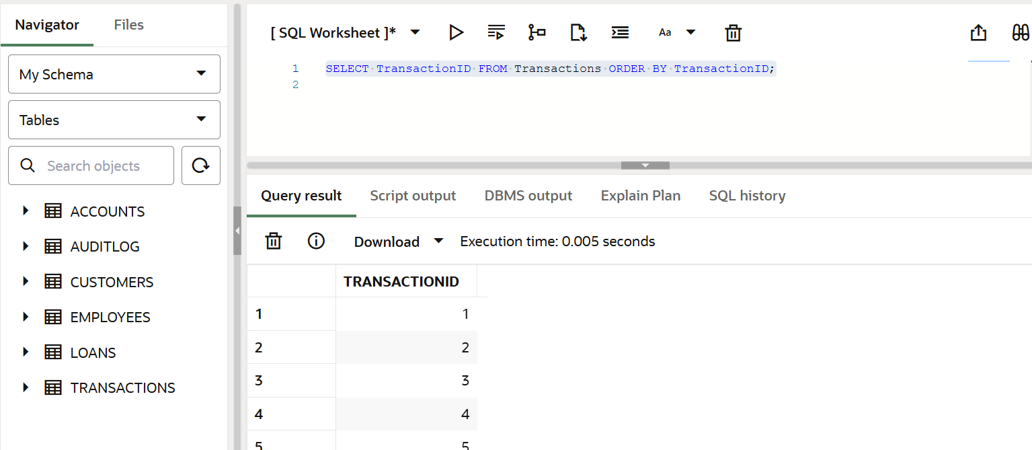

**Scenario 3:** Enforce business rules on deposits and withdrawals.

* + **Question:** Write a trigger **CheckTransactionRules** that ensures withdrawals do not exceed the balance and deposits are positive before inserting a record into the Transactions table.

CREATE OR REPLACE TRIGGER CheckTransactionRules

BEFORE INSERT ON Transactions

FOR EACH ROW

DECLARE

  v_balance NUMBER;

BEGIN

  IF :NEW.TransactionType = 'Deposit' AND :NEW.Amount <= 0 THEN

    RAISE_APPLICATION_ERROR(-20001, 'Deposit amount must be positive.');

  END IF;

   IF :NEW.TransactionType = 'Withdrawal' THEN

    SELECT Balance INTO v_balance

    FROM Accounts

    WHERE AccountID = :NEW.AccountID;

    IF :NEW.Amount > v_balance THEN

      RAISE_APPLICATION_ERROR(-20002, 'Withdrawal amount exceeds account balance.');

    END IF;

  END IF;

END;

/

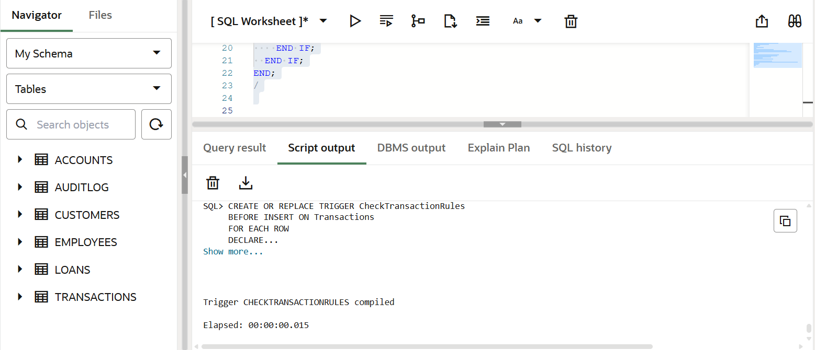

**Exercise 6: Cursors**

**Scenario 1:** Generate monthly statements for all customers.

* + **Question:** Write a PL/SQL block using an explicit cursor **GenerateMonthlyStatements** that retrieves all transactions for the current month and prints a statement for each customer.

DECLARE

  CURSOR trans_cursor IS

    SELECT c.CustomerID, c.Name, t.TransactionID, t.TransactionDate,

           t.Amount, t.TransactionType

    FROM Customers c

    JOIN Accounts a ON c.CustomerID = a.CustomerID

    JOIN Transactions t ON a.AccountID = t.AccountID

    WHERE TO_CHAR(t.TransactionDate, 'MMYYYY') = TO_CHAR(SYSDATE, 'MMYYYY')

    ORDER BY c.CustomerID, t.TransactionDate;

  v_cust_id     Customers.CustomerID%TYPE;

  v_name        Customers.Name%TYPE;

  v_trans_id    Transactions.TransactionID%TYPE;

  v_trans_date  Transactions.TransactionDate%TYPE;

  v_amount      Transactions.Amount%TYPE;

  v_type        Transactions.TransactionType%TYPE;

  v_last_cust   NUMBER := -1;

BEGIN

  DBMS_OUTPUT.PUT_LINE('--- Monthly Statements for ' || TO_CHAR(SYSDATE, 'Month YYYY') || ' ---');

  OPEN trans_cursor;

  LOOP

    FETCH trans_cursor INTO v_cust_id, v_name, v_trans_id, v_trans_date, v_amount, v_type;

    EXIT WHEN trans_cursor%NOTFOUND;

    IF v_cust_id != v_last_cust THEN

      DBMS_OUTPUT.PUT_LINE(CHR(10) || 'Customer: ' || v_name || ' (ID: ' || v_cust_id || ')');

      DBMS_OUTPUT.PUT_LINE('Date       | Type       | Amount');

      DBMS_OUTPUT.PUT_LINE('-----------|------------|--------');

      v_last_cust := v_cust_id;

    END IF;

    DBMS_OUTPUT.PUT_LINE(

      TO_CHAR(v_trans_date, 'DD-Mon-YYYY') || ' | ' ||

      RPAD(v_type, 10) || ' | ' ||

      TO_CHAR(v_amount, '99999.99')

    );

  END LOOP;

  CLOSE trans_cursor;

END;

/

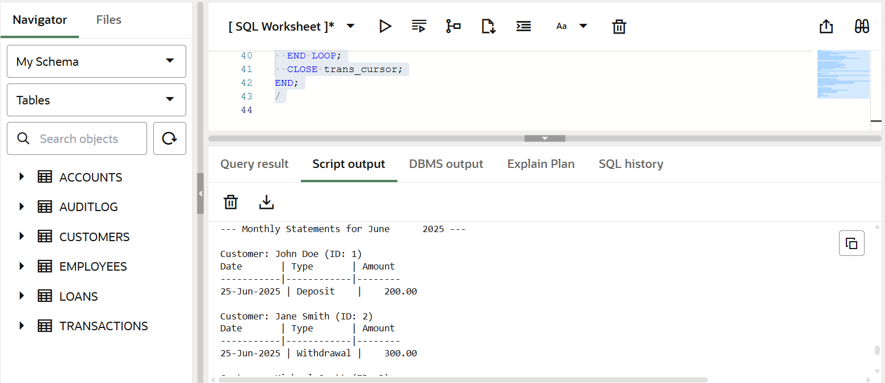

**Scenario 2:** Apply annual fee to all accounts.

* + **Question:** Write a PL/SQL block using an explicit cursor **ApplyAnnualFee** that deducts an annual maintenance fee from the balance of all accounts.

DECLARE

  CURSOR acc_cursor IS

    SELECT AccountID, Balance

    FROM Accounts

    FOR UPDATE;

  v_account_id Accounts.AccountID%TYPE;

  v_balance    Accounts.Balance%TYPE;

  v_fee CONSTANT NUMBER := 100; -- Annual fee amount

BEGIN

  OPEN acc_cursor;

  LOOP

    FETCH acc_cursor INTO v_account_id, v_balance;

    EXIT WHEN acc_cursor%NOTFOUND;

    -- Only deduct if balance is enough

    IF v_balance >= v_fee THEN

      UPDATE Accounts

      SET Balance = Balance - v_fee

      WHERE AccountID = v_account_id;

      DBMS_OUTPUT.PUT_LINE('Annual fee of ₹' || v_fee || ' deducted from Account ID: ' || v_account_id ||

                           ' | New Balance: ₹' || TO_CHAR(v_balance - v_fee, '99999.99'));

    ELSE

      DBMS_OUTPUT.PUT_LINE('Skipping Account ID: ' || v_account_id || ' due to insufficient balance.');

    END IF;

  END LOOP;

  CLOSE acc_cursor;

  COMMIT;

END;

/

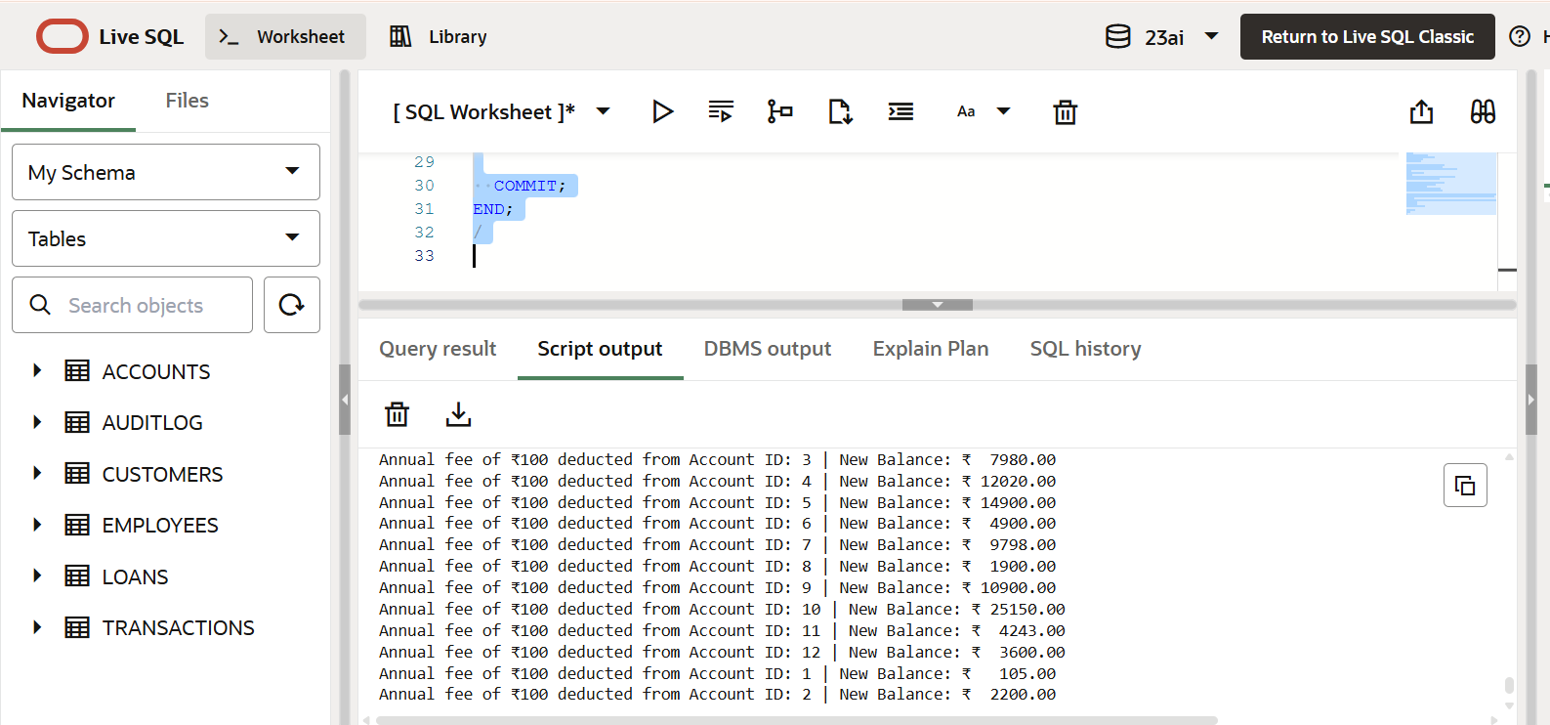

**Scenario 3:** Update the interest rate for all loans based on a new policy.

* + **Question:** Write a PL/SQL block using an explicit cursor **UpdateLoanInterestRates** that fetches all loans and updates their interest rates based on the new policy.

DECLARE

  CURSOR loan_cursor IS

    SELECT LoanID, LoanAmount, InterestRate, StartDate

    FROM Loans

    FOR UPDATE;

  v_loan_id      Loans.LoanID%TYPE;

  v_loan_amt     Loans.LoanAmount%TYPE;

  v_rate         Loans.InterestRate%TYPE;

  v_start_date   Loans.StartDate%TYPE;

  v_new_rate     NUMBER;

BEGIN

  OPEN loan_cursor;

  LOOP

    FETCH loan_cursor INTO v_loan_id, v_loan_amt, v_rate, v_start_date;

    EXIT WHEN loan_cursor%NOTFOUND;

    v_new_rate := v_rate;

    -- Apply new policy

    IF v_loan_amt > 50000 THEN

      v_new_rate := v_new_rate - 1;

    END IF;

    IF MONTHS_BETWEEN(SYSDATE, v_start_date) > 36 THEN

      v_new_rate := v_new_rate - 0.5;

    END IF;

    -- Update only if the rate changed

    IF v_new_rate != v_rate THEN

      UPDATE Loans

      SET InterestRate = v_new_rate

      WHERE LoanID = v_loan_id;

      DBMS_OUTPUT.PUT_LINE('Loan ID ' || v_loan_id || ' updated | Old Rate: ' || v_rate ||

                           ' -> New Rate: ' || v_new_rate);

    ELSE

      DBMS_OUTPUT.PUT_LINE('Loan ID ' || v_loan_id || ' has no change in interest rate.');

    END IF;

  END LOOP;

  CLOSE loan_cursor;

  COMMIT;

END;

/

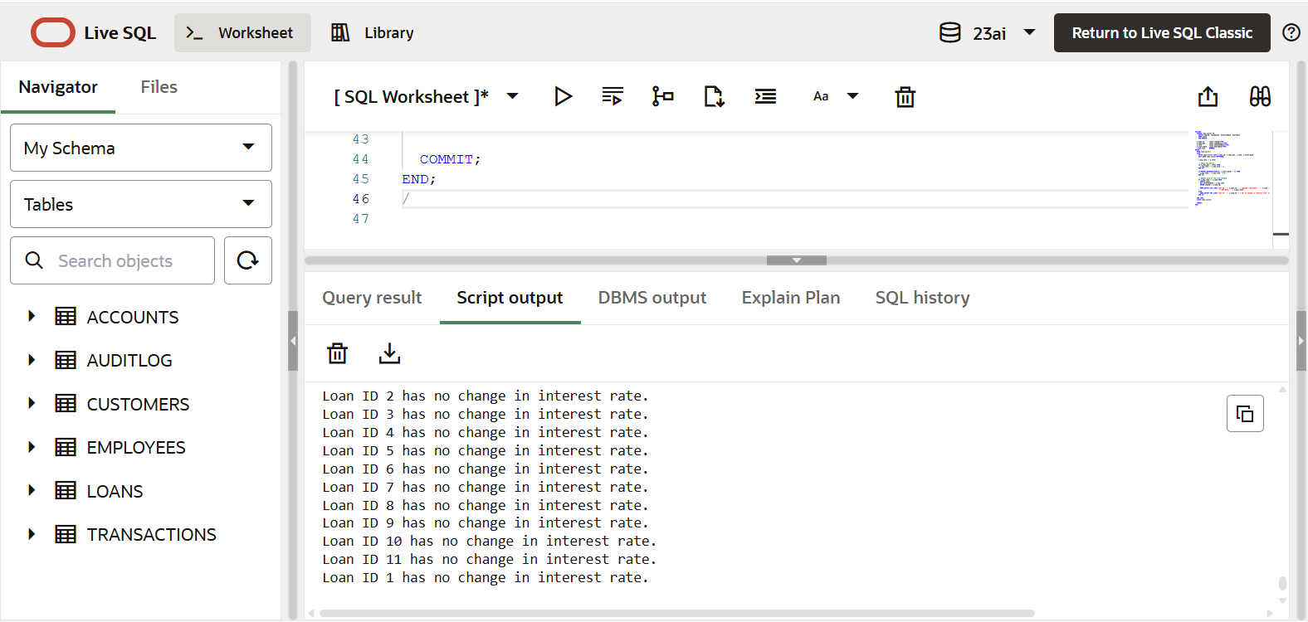

**Exercise 7: Packages**

**Scenario 1:** Group all customer-related procedures and functions into a package.

* + **Question:** Create a package **CustomerManagement** with procedures for adding a new customer, updating customer details, and a function to get customer balance.

CREATE OR REPLACE PACKAGE CustomerManagement AS

  PROCEDURE AddCustomer(

    p_customer_id IN NUMBER,

    p_name        IN VARCHAR2,

    p_dob         IN DATE,

    p_balance     IN NUMBER

  );

  PROCEDURE UpdateCustomerDetails(

    p_customer_id IN NUMBER,

    p_name        IN VARCHAR2,

    p_dob         IN DATE

  );

  FUNCTION GetCustomerBalance(

    p_customer_id IN NUMBER

  ) RETURN NUMBER;

END CustomerManagement;

/

CREATE OR REPLACE PACKAGE BODY CustomerManagement AS

  PROCEDURE AddCustomer(

    p_customer_id IN NUMBER,

    p_name        IN VARCHAR2,

    p_dob         IN DATE,

    p_balance     IN NUMBER

  ) IS

  BEGIN

    INSERT INTO Customers (CustomerID, Name, DOB, Balance, LastModified)

    VALUES (p_customer_id, p_name, p_dob, p_balance, SYSDATE);

    DBMS_OUTPUT.PUT_LINE('Customer added successfully: ' || p_name);

  EXCEPTION

    WHEN DUP_VAL_ON_INDEX THEN

      DBMS_OUTPUT.PUT_LINE('Customer ID already exists.');

    WHEN OTHERS THEN

      DBMS_OUTPUT.PUT_LINE('Error: ' || SQLERRM);

  END;

  PROCEDURE UpdateCustomerDetails(

    p_customer_id IN NUMBER,

    p_name        IN VARCHAR2,

    p_dob         IN DATE

  ) IS

  BEGIN

    UPDATE Customers

    SET Name = p_name,

        DOB = p_dob,

        LastModified = SYSDATE

    WHERE CustomerID = p_customer_id;

    IF SQL%ROWCOUNT = 0 THEN

      DBMS_OUTPUT.PUT_LINE('Customer not found.');

    ELSE

      DBMS_OUTPUT.PUT_LINE('Customer details updated.');

    END IF;

  END;

  FUNCTION GetCustomerBalance(

    p_customer_id IN NUMBER

  ) RETURN NUMBER IS

    v_balance NUMBER;

  BEGIN

    SELECT NVL(SUM(Balance), 0)

    INTO v_balance

    FROM Accounts

    WHERE CustomerID = p_customer_id;

    RETURN v_balance;

  EXCEPTION

    WHEN NO_DATA_FOUND THEN

      RETURN 0;

  END;

END CustomerManagement;

/

BEGIN

  CustomerManagement.AddCustomer(3, 'Kavi Kumar', TO_DATE('1995-10-10','YYYY-MM-DD'), 2000);

  CustomerManagement.UpdateCustomerDetails(3, 'Kavi K.', TO_DATE('1995-10-10','YYYY-MM-DD'));

  DBMS_OUTPUT.PUT_LINE('Balance: ₹' || CustomerManagement.GetCustomerBalance(3));

END;

/

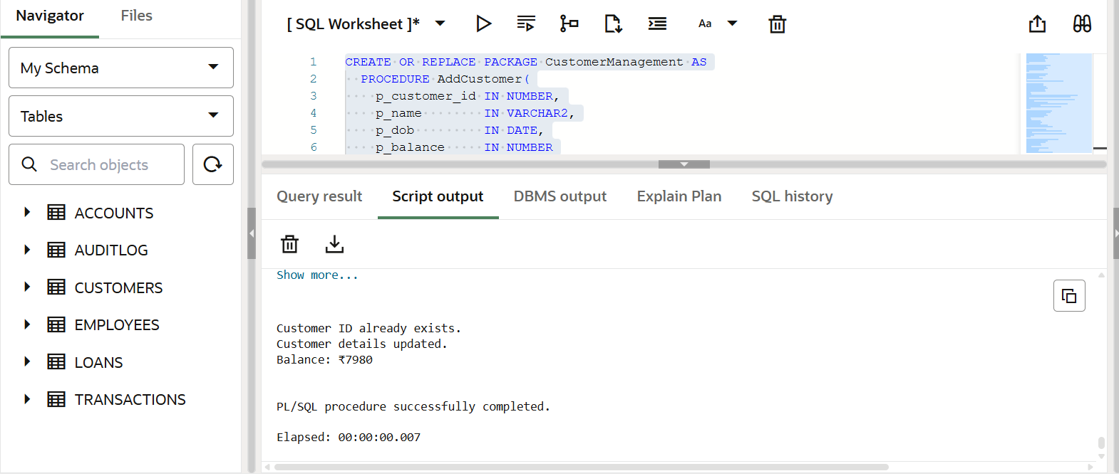

**Scenario 2:** Create a package to manage employee data.

* + **Question:** Write a package **EmployeeManagement** with procedures to hire new employees, update employee details, and a function to calculate annual salary.

CREATE OR REPLACE PACKAGE EmployeeManagement AS

  PROCEDURE HireEmployee(

    p_emp_id     IN NUMBER,

    p_name       IN VARCHAR2,

    p_position   IN VARCHAR2,

    p_salary     IN NUMBER,

    p_department IN VARCHAR2,

    p_hire_date  IN DATE

  );

  PROCEDURE UpdateEmployeeDetails(

    p_emp_id     IN NUMBER,

    p_name       IN VARCHAR2,

    p_position   IN VARCHAR2,

    p_department IN VARCHAR2

  );

  FUNCTION GetAnnualSalary(

    p_emp_id IN NUMBER

  ) RETURN NUMBER;

END EmployeeManagement;

/

CREATE OR REPLACE PACKAGE BODY EmployeeManagement AS

  -- 1. Hire new employee

  PROCEDURE HireEmployee(

    p_emp_id     IN NUMBER,

    p_name       IN VARCHAR2,

    p_position   IN VARCHAR2,

    p_salary     IN NUMBER,

    p_department IN VARCHAR2,

    p_hire_date  IN DATE

  ) IS

  BEGIN

    INSERT INTO Employees (EmployeeID, Name, Position, Salary, Department, HireDate)

    VALUES (p_emp_id, p_name, p_position, p_salary, p_department, p_hire_date);

    DBMS_OUTPUT.PUT_LINE('Employee hired: ' || p_name);

  EXCEPTION

    WHEN DUP_VAL_ON_INDEX THEN

      DBMS_OUTPUT.PUT_LINE('Employee ID already exists.');

    WHEN OTHERS THEN

      DBMS_OUTPUT.PUT_LINE('Error: ' || SQLERRM);

  END;

  -- 2. Update employee details

  PROCEDURE UpdateEmployeeDetails(

    p_emp_id     IN NUMBER,

    p_name       IN VARCHAR2,

    p_position   IN VARCHAR2,

    p_department IN VARCHAR2

  ) IS

  BEGIN

    UPDATE Employees

    SET Name = p_name,

        Position = p_position,

        Department = p_department

    WHERE EmployeeID = p_emp_id;

    IF SQL%ROWCOUNT = 0 THEN

      DBMS_OUTPUT.PUT_LINE(' Employee not found.');

    ELSE

      DBMS_OUTPUT.PUT_LINE('Employee details updated.');

    END IF;

  END;

  -- 3. Get annual salary

  FUNCTION GetAnnualSalary(

    p_emp_id IN NUMBER

  ) RETURN NUMBER IS

    v_salary NUMBER;

  BEGIN

    SELECT Salary INTO v_salary

    FROM Employees

    WHERE EmployeeID = p_emp_id;

    RETURN v_salary * 12;

  EXCEPTION

    WHEN NO_DATA_FOUND THEN

      RETURN 0;

  END;

END EmployeeManagement;

/

BEGIN

  EmployeeManagement.HireEmployee(

    3, 'Sahana Raj', 'Analyst', 40000, 'Finance', TO_DATE('2024-09-01', 'YYYY-MM-DD')

  );

  EmployeeManagement.UpdateEmployeeDetails(3, 'Sahana R.', 'Senior Analyst', 'Finance');

  DBMS_OUTPUT.PUT_LINE('Annual Salary: ₹' || EmployeeManagement.GetAnnualSalary(3));

END;

/

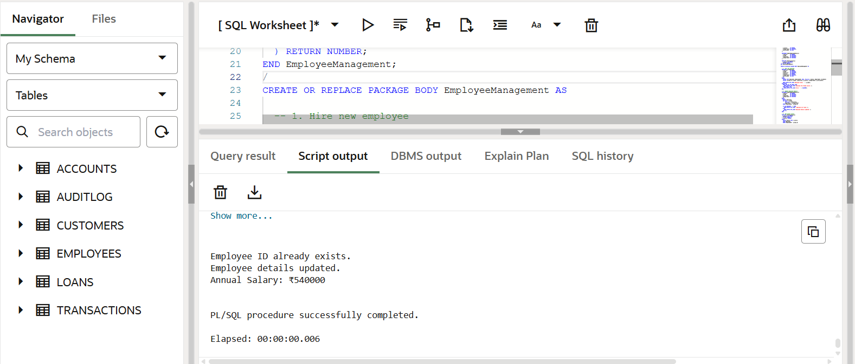

**Scenario 3:** Group all account-related operations into a package.

* + **Question:** Create a package **AccountOperations** with procedures for opening a new account, closing an account, and a function to get the total balance of a customer across all accounts.

CREATE OR REPLACE PACKAGE AccountOperations AS

  PROCEDURE OpenAccount(

    p_account_id   IN NUMBER,

    p_customer_id  IN NUMBER,

    p_account_type IN VARCHAR2,

    p_balance      IN NUMBER

  );

  PROCEDURE CloseAccount(

    p_account_id IN NUMBER

  );

  FUNCTION GetTotalBalance(

    p_customer_id IN NUMBER

  ) RETURN NUMBER;

END AccountOperations;

/

CREATE OR REPLACE PACKAGE BODY AccountOperations AS

  PROCEDURE OpenAccount(

    p_account_id   IN NUMBER,

    p_customer_id  IN NUMBER,

    p_account_type IN VARCHAR2,

    p_balance      IN NUMBER

  ) IS

  BEGIN

    INSERT INTO Accounts (

      AccountID, CustomerID, AccountType, Balance, LastModified

    ) VALUES (

      p_account_id, p_customer_id, p_account_type, p_balance, SYSDATE

    );

    DBMS_OUTPUT.PUT_LINE('Account opened successfully: ID ' || p_account_id);

  EXCEPTION

    WHEN DUP_VAL_ON_INDEX THEN

      DBMS_OUTPUT.PUT_LINE('Account ID already exists.');

    WHEN OTHERS THEN

      DBMS_OUTPUT.PUT_LINE('Error: ' || SQLERRM);

  END;

  PROCEDURE CloseAccount(

    p_account_id IN NUMBER

  ) IS

  BEGIN

    DELETE FROM Accounts

    WHERE AccountID = p_account_id;

    IF SQL%ROWCOUNT = 0 THEN

      DBMS_OUTPUT.PUT_LINE('Account not found.');

    ELSE

      DBMS_OUTPUT.PUT_LINE('Account closed: ID ' || p_account_id);

    END IF;

  END;

  FUNCTION GetTotalBalance(

    p_customer_id IN NUMBER

  ) RETURN NUMBER IS

    v_total_balance NUMBER;

  BEGIN

    SELECT NVL(SUM(Balance), 0)

    INTO v_total_balance

    FROM Accounts

    WHERE CustomerID = p_customer_id;

    RETURN v_total_balance;

  EXCEPTION

    WHEN NO_DATA_FOUND THEN

      RETURN 0;

  END;

END AccountOperations;

/

BEGIN

  AccountOperations.OpenAccount(3, 1, 'Savings', 2500);

  AccountOperations.CloseAccount(2);

  DBMS_OUTPUT.PUT_LINE('Total balance for Customer 1: ₹' ||

                       AccountOperations.GetTotalBalance(1));

END;

/

